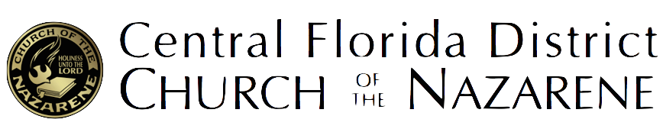

Central Florida District Churches of the Nazarene

I. Mission and Vision

Our Vision: Together strengthening existing churches and partnering with them in starting new ones.

Our Mission: Together strengthening existing churches and partnering with them in starting new ones. . .

By every Church . . .

1. Becoming an Intentional House of Prayer

2. Embracing Mission Action Planning

God has a unique plan
for His unique church
in your unique neighborhood

3. Together, reaching 1200 New Nazarenes Annually

4. Weekly posting Vital Signs

5. Intentionally Making Christlike Disciples

6. Developing Healthy Pastors

7. 100% Funding the Mission

Fair Share 8 % World Evangelism 5.5%

8. Modeling of the Centrality of God’s Word
9. Proclaiming and living the Holy Life

10. Together Starting 60 New Churches by 2020

II. Pastoral Leadership Development

Studies, Credentialing and Ordination

Mentoring

CrossTraining

Pastor’s Spiritual Development

District Communications

District Assemblies

Ethnic/Gender Inclusion

Mission Area Coordinators

