Sabbatical Policy

In accordance with *Manual* paragraph 222.9. “In order to encourage a healthy superintendency and the lifelong learning of the district superintendent, the District Advisory Board, in consultation with the general superintendent in jurisdiction, should provide a sabbatical leave for the district superintendent following each seven consecutive years of service to the district.  During the sabbatical, the district superintendent’s salary will continue in full. The district superintendent shall work with the District Advisory Board to develop a proposal for the sabbatical including duration, personal development plan, and a plan to care for essential duties during the sabbatical period.”

Dr. Dahl will be away October 13, 2014 and return January 8, 2015; this follows Clergy Soul Care Retreat and is returning prior to Pastoral Assessment Center. Dr. Dahl will use the Sabbatical time to rest and rejuvenate and undertake future planning for the district.

DISTRICT SUPERINTENDENT’S

**SABBATICAL**

October 13, 2014 – January 8, 2015

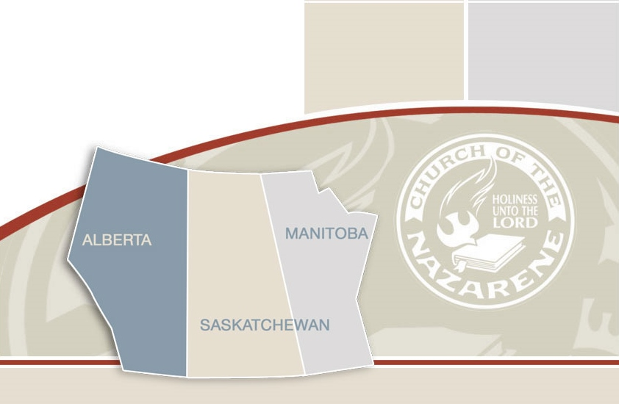

Canada West District Church of the Nazarene

Canada West District Church of the Nazarene

1243 Erin Drive SE

Phone: 403-912-3043

Fax: 403-912-3043

www.cwdnazarene.org

**Questions and Answers**

**What if there is a crisis in a local Church?**

*Response to crisis in the local church is currently decided by the District Advisory Board. The District Advisory Board under the direction of the Board Secretary will be available should a need arise.*

**What about local churches without a Pastor?**

*Interim pastoral arrangements will be put into place, if they have not been already, during the time of the sabbatical.*

**Will the District Superintendent be available if there is an emergency?**

*Yes, the District Advisory Board has identified trigger points to guide when the District Superintendent will be called. In the event of an emergency call Rose Graham, who will then contact the District Superintendent.*

**Who will handle the administrative responsibilities?**

*Most administrative duties associated with the District Superintendent’s role can be handled by personnel presently in place. Routine correspondence between churches, other district leaders and Global Ministry Center is presently being handled through the District office and the District Administrator.*

**What about items requiring District Superintendent oversight?**

*Pastoral and church board reviews, candidate interviews, etc. will be scheduled prior to the Sabbatical.*

**Is the district financially prepared for the District Superintendent to go on sabbatical?**

*Yes. The Finance committee has prepared in advance for the sabbatical and the 2014/2015 budget has been structured to accommodate accordingly.*

**WHO TO CALL**

|  |  |
| --- | --- |
| General Inquiries | District office  403-912-3043 |
| Emergencies | Rose Graham  403-912-3043  403-948-7123  403-880-6042 |
| District Advisory Board Secretary | To be announced |