Who Is a Member of the District Assembly?
Who Is a Member of the District Conventions?
(A compiled and edited document, prepared by Brian E. Wilson, Updated March 3, 2018)

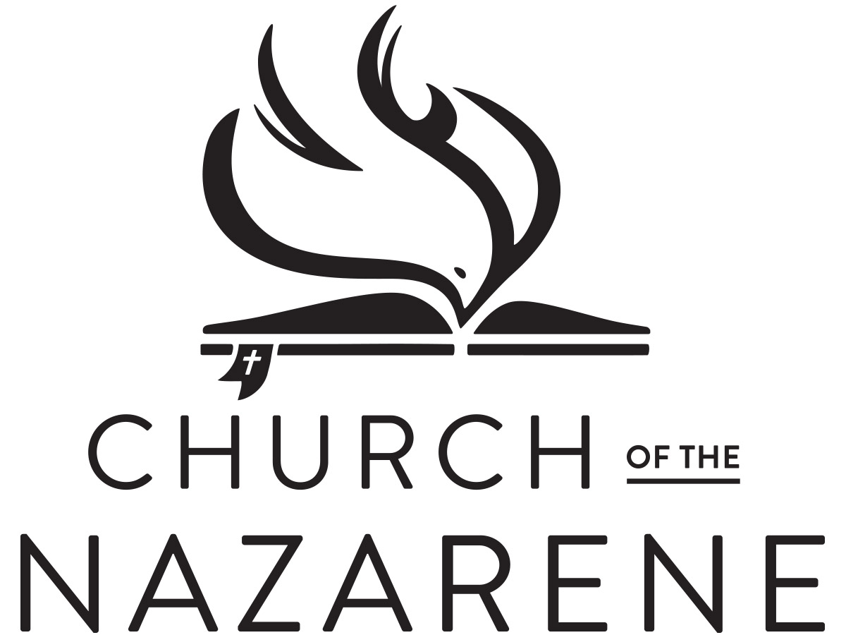
District Assembly
Manual 201: Membership of the District Assembly
The district assembly shall be composed of
the following ex officio (by virtue of office) members:
- All assigned elders
- All assigned deacons
- All assigned district-licensed ministers
- The district secretary
- The district treasurer
- Chairpersons of standing district committees reporting to the District Assembly
- Any lay presidents of Nazarene institutions of higher education, whose local church membership is on the district.
- The District SDMI chairperson (Sunday School and Discipleship International)
- District age-group ministries international directors (children and adult)
- The District SDMI Board
- The president of the District NYI (Nazarene Youth International)
- The president of the District NMI (Nazarene Missions International)
- The newly elected superintendent or vice superintendent of each local SDMI Board
- The newly elected president or vice president of each local NYI
- The newly elected president or vice president of each local NMI
- (OR) an elected alternate may represent the local NMI, NYI, and SDMI organizations in the district assembly
- The lay members of the District Advisory Board
- Active lay missionaries whose local church membership is on the district
- All retired lay missionaries whose local church membership is on the district who were active missionaries at the time of retirement
In addition to the ex officio delegates, each local church and church-type mission in the assembly district may send locally-elected lay delegates as members of the District Assembly. To determine the number of delegates each church may elect, use the following chart for districts over 5,000 members, including Southern Florida:

Number of Number of Number of Number of
Full members delegates Full members delegates
0-75 1 326-375 7
76-125 2 376-425 8
126-175 3 426-475 9
176-225 4 476-525 10
226-275 5 526-575 11
276-325 6 576-625 12
- If a church is eligible for more than 12 or 13 delegates, continue the chart pattern to reach the total number of delegates allowed for the church membership.
- Ιf the church is a church-type mission which has members, the Board of General Superintendents issued a ruling in 1998 that the pastor may name the eligible delegates based on the chart above.

NYI Convention
(Nazarene Youth International)
Manual 910.219: District NYI Convention
The District NYI Convention is composed of the following ex officio (by virtue of office) members:
- Newly elected local NYI presidents
- Youth pastors
- Local senior pastors and co-pastors
- The district superintendent
- The members of the District NYI Council
- Other assigned ordained ministers of the district who participate in NYI ministry
- Full time pastoral staff members of the local church who participate in NYI ministry
In addition to the ex officio delegates, the local church may elect a number of local NYI delegates according to the chart below. All local NYI delegates must be members of the local Church of the Nazarene that they represent.
Number of Number of Number of Number of
NYI members delegates NYI members delegates
5-45 4 136-165 8
46-75 5 166-195 9
76-105 6 196-225 10
106-135 7 226-255 11

SDMI Convention
(Sunday School and
Discipleship Ministries
International)
Manual 812, Article VIII, Section 1 – District SDMI Convention:
Membership of the District NMI Convention:
Ex officio (by virtue of office) members of the convention shall be:
- The district superintendent
- All pastors
- All assigned ordained ministers
- All assigned district licensed ministers
- All retired assigned ministers
- All full-time associates
- The district SDMI chair
- District directors of Children’s Ministries and Adult Ministries
- All local SDMI superintendents
- All local Children’s Ministries and Adult Ministries directors
- All local NYI presidents
- Elected members of the District SDMI Board
- Lay members of the District Advisory Board
- Any Nazarene full-time professors of Christian education with membership on the district
- Field, regional and global SDMI officers
In addition to the ex officio members, each local church may elect SDMI delegates. The number of additional delegates allowed shall be 25 percent of the number of officers, teachers, and leaders of the local SDMI ministries. In case elected delegates cannot attend the convention, alternate delegates shall be designated in the order of the votes received. All local SDMI delegates must be members of the local Church of the Nazarene that they represent.

Number of local SDMI Number of Number of local SDMI Number of
officers/teachers/leaders delegates officers/teachers/leaders delegates
1-4 1 17-20 5
5-8 2 21-24 6
9-12 3 25-28 7
13-16 4 29-32 8

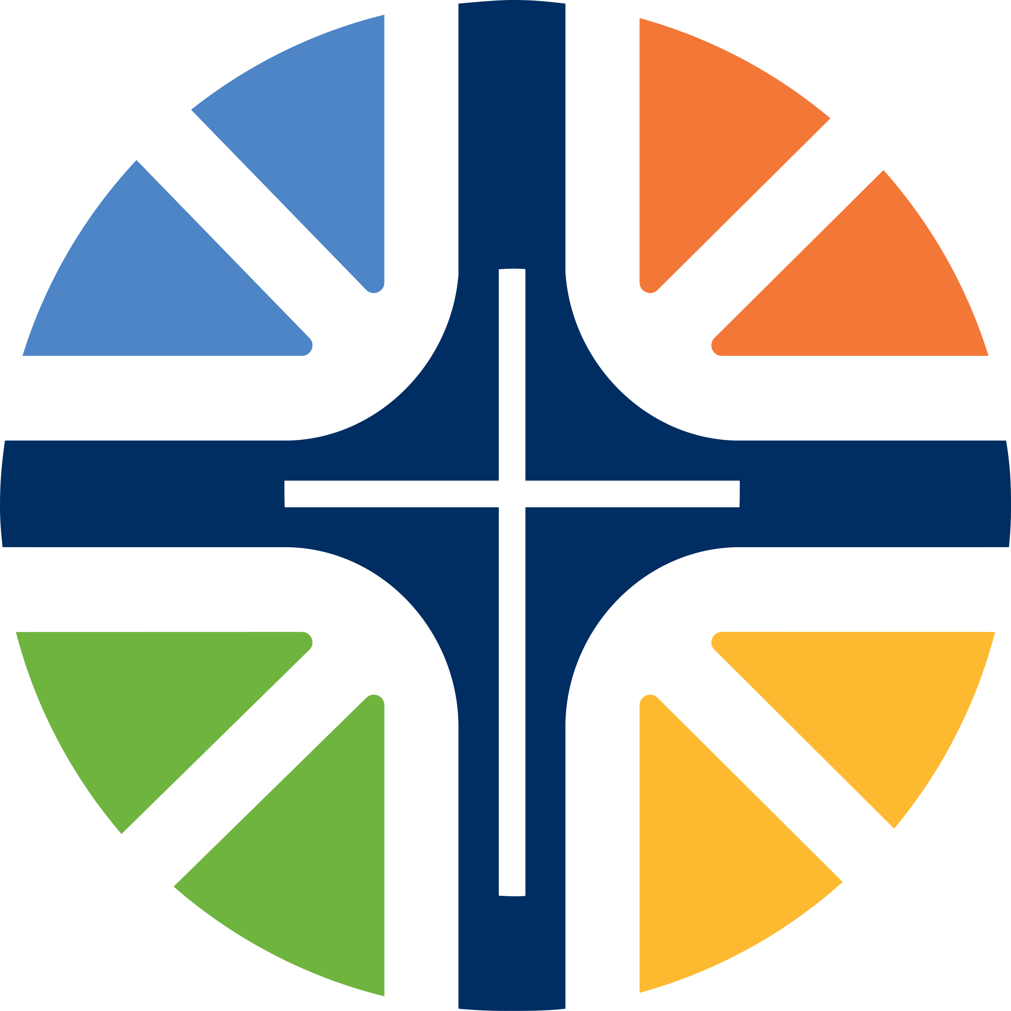
NMI Convention
(Nazarene Missions International)
Manual 811, Article VI, Section 3 – District NMI Meetings:

Membership of the District NMI Convention -- Only members of the respective district shall be eligible to serve as ex officio (by virtue of office) or elected delegates
Ex officio members of the convention shall be:
- The district NMI council
- The district superintendent
- All assigned ministers (this includes all district-licensed and ordained ministers who are serving in an assigned ministry role, such as pastors and associate pastors).
- Full time lay staff members of local churches, who are responsible for a local ministry area*
- Lay members of the district advisory board
- The local NMI presidents of the assembly year just ending and newly elected NMI presidents or newly elected vice presidents if the newly elected president cannot attend.
- Global NMI council members
- Retired assigned ministers
- Retired missionaries
- Missionaries on home assignment
- Missionary appointees
- Any former district presidents who retain their membership on the district
In addition to the ex officio delegates, the local church or church-type mission may elect local NMI delegates to the District NMI Convention. These delegates shall be elected from among the local NMI members (15 years of age or older). The number of maximum elected delegates shall be based on the following formula: two delegates from each local NMI of 25 [NMI] members or fewer, and one additional delegate for each additional 25 members or major portion thereof. Membership shall be based on the NMI membership reported at the local NMI annual meeting when elections take place.

Number of local Number of Number of local Number of
NMI members delegates NMI members delegates
0-37 2 163-187 8
38-67 3 188-212 9
68-87 4 213-237 10
88-112 5 238-262 11
113-137 6 263-287 12
138-162 7 288-312 13

*This item (#4) in the listing is a redacted expression of what appears in the 2017-2021 Manual as “full-time salaried associate ministers of local churches”. The intent of the Manual phrase was to include those lay persons who do not hold a ministerial credential, but who have full time responsibility for an area of local ministry, such as youth ministry or children’s ministry. Assigned, credentialed senior pastors and associate ministers, whether full time or part time, would already be included in #3 of this list.

