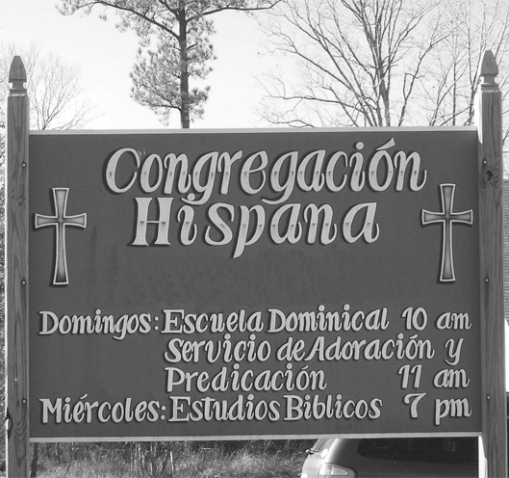

A Preface to the Statement of Understanding
  - Multi-Congregational Resource Series
This paper, by Tom Nees, former Mission Strategy Director, can be read as a preface to the Statement of Understanding (found on www.usacanadaregion.org in PDF form) or as an informative perspective on the issue of multi-congregational ministry.

A Preface to the Statement of Understanding
  - Multi-Congregational Resource Series
  - Tom Nees, Former Director of the U.S./Canada Mission Evangelism Department, Church of the Nazarene

Using church buildings for more than one congregation has provided an effective way to start congregations among immigrant people who want and need to worship in their own language and culture. Typically these guest congregations are invited by host congregations to share space and arrange schedules so that two—sometimes three or more—groups can develop their distinct ministries in one building.
Since congregations are, or should be, like families it comes as no surprise that congregations will refer to a church building as home. Thus the invitation, "Our church can be your home." When a guest congregation is invited to take up residence in a "church home" without merging with the "church family," certain dynamics can be set in motion that may result in a mixed blessing.
Agreements between host and guest congregations to share space is usually driven by a desire to start new churches, as well as to make good use of limited facilities. Congregations typically view the arrangement as an effective way to reach people who would not otherwise be included in the life of host congregations. Since most church buildings are under-utilized much—if not most—of the time, using a sanctuary and Sunday School rooms more than an hour or two a week by a single congregation can be good stewardship.
More immigrant churches are being started and are often growing faster than churches among the native-born population. This is due in part to the offer made by congregations to new immigrant congregations of affordable, often free, space in church buildings. In transitional neighborhoods, it is not unusual now for a growing guest congregation to take over a building from a moving or declining host congregation. These new immigrant congregations have filled church buildings, keeping them open in neighborhoods that would have otherwise been without the church's presence.
Sharing space with host congregations has made it possible for new congregations to start without prohibitive property and building costs. As these new congregations grow, they are often able to compensate the host congregation for expenses and thus represent a potential financial benefit to them. However, if that relationship takes on the characteristics of landlord-tenant, dissatisfaction usually follows.
Unless culturally distinct congregations intend to eventually merge, shared-space arrangements need to be understood as temporary and transitional. Even if the multiple use of a building is feasible, most guest congregations want their own building. Likewise, most host congregations eventually desire exclusive use of their facility, unless they are aware that their present site has a limited future. There are exceptions, but current information leads me to conclude that, at best, multiple use of a church property requires compromises for everyone and careful consideration of differing and sometimes conflicting needs and responsibilities are necessary.
Shared-space ministries are not unlike two families living together in one home. Immediately following the Vietnam War, our family decided to sponsor a refugee family. A member of our congregation, who had spent time as a wartime consultant in Saigon, was desperately trying to find a home for a family with six children. The family was interned in a crowded refugee camp in Arkansas. We agreed to sponsor this family. This father and mother, with their six children, became guests of our family, with four children in our four-bedroom parsonage. In spite of the language barrier and the cramped quarters, it turned out to be a wonderful experience for everyone. It could have been otherwise.
Even though we didn't have a formal agreement, we all understood this was not a permanent arrangement, and furthermore, that none of us intended to merge the families. We divided up the bedrooms, shared common space, and ate most of our meals together. The children soon became friends. As an added benefit, the wife was a gourmet cook and professional seamstress. In a relatively short period of time, we were able to help the husband find a job and then relocate our guests in an affordable apartment that I was able to secure. These refugees became our life-long friends.
I can only imagine the problems that could have occurred if these guests in our home had not been interested in finding work and their own living arrangements. Or if we had decided that we needed their financial support in order to buy food and help pay household expenses. If we were to consider doing this again, I think I would insist on more discussion beforehand, with some written statement of understanding to prevent disagreement and misunderstanding.
Our family and home experience is more than a metaphor for shared-space ministries. If anything, it underscores the intense personal issues that are likely to emerge when congregations choose to meet separately in the same building.
A document that our office has recently developed, a Statement of Understanding, is intended to encourage the multiple use of church buildings where such arrangements foster evangelism and the development of new churches, especially among immigrants. Immigrants quickly become permanent residents. Soon they will become citizens. Their children will be native-born children of immigrants like most of the rest of the population. And they will become a more important part of the church as society becomes increasingly multicultural.
While the relationship between most host and guest congregations is amicable, we are aware of enough problems to make careful planning and constant evaluation necessary. The Statement of Understanding is a model or outline intended to give shape and structure to those engaging in shared-space ministry, as well as prevent potential misunderstanding. Since many variations of the multi-congregational or shared-space concept exist, the content of the Statement can be contextualized and modified to more accurately fit a local situation. This document is intended to have a broad application, so the Statement will be subject to review and revision as needed.
The immigrant church represents a missionary harvest field in our own neighborhoods and cities. Many immigrants are converts of missionary work in other countries. Some of the immigrant church leaders were trained and ordained by the church in international areas and are now ready to find their place of leadership within the Church of the Nazarene in the United States and Canada.

