**Strategic Priority #4 -- Passionate Missional Outreach**

**Release and encourage our people to embrace with open arms and hearts both the needy and the new people groups among us.**

**Peer to Peer Learning Moments**

While “Passionate Missional Outreach” could be defined in many ways, Strategic Priority #4 is defined above, and in the book *A Holy Purpose*, in a way that focuses on what we often refer to as “Ethnic Ministries” and “Compassionate Ministries”. Attached are several resource items that may be helpful to you. In addition, Roberto Hodgson and Jay Height are two key GMC personnel for us in these two areas, respectively ([rhodgson@nazarene.org](mailto:rhodgson@nazarene.org) and [jheight@nazarene.org](mailto:jheight@nazarene.org) ). The starting point for denominational resources on the web: [www.usacanadaregion.org](http://www.usacanadaregion.org)

Our goal today is to learn from each other. The following questions might be appropriate starter questions for us: ***As it relates to ethnic ministries and compassionate ministries:***

**Vision:**

* What is your vision, how have you developed your vision, and how have you communicated your vision on your district?
* How have you moved from vision to strategic implementation?

**District/Local Church Collaboration:**

* In what ways are you seeing district and local church collaborations helpful?
* For starting new ethnic-specific congregations, multicultural congregations, hosting of congregations, funding of congregations, resources
* For compassionate ministries? Nazarene Disaster Response? Work and Witness?

**District Personnel:**

* How are you organizing district personnel or otherwise providing district leadership for these two areas?
* Ethnic Ministries and Compassionate Ministries Coordinators or Facilitators, Contact Persons
* Role of the DS?

**District Program/Development**

* What ethnic-specific district activities or events have you found helpful for training and fellowship? How do you balance ethnic-specific events with all-inclusive district events?

**Other questions/issues of relevance to Strategic Priority #4**

* Ministerial Training in non-English languages
* Legal/immigration issues
* How does regional/national strategy integrate with district strategies?

**What else is on your mind? What are your learning discovering as you lead your district in passionate missional outreach?**

**Ethnic Ministries**

**Understanding the reality of our mission field in the USA/Canada.**

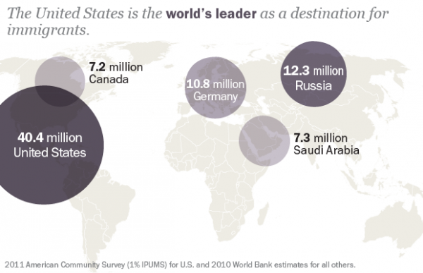

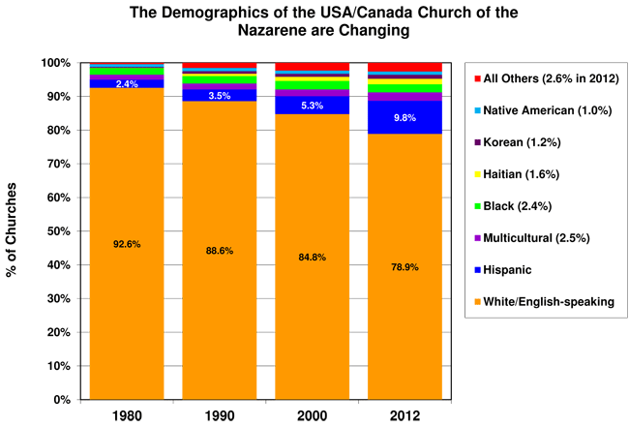

**Immigrant Population in Canada:**

**The following website provides a recent report on the immigrant population in Canada:**

**http://news.nationalpost.com/2013/05/08/young-suburban-and-mostly-asian-canadas-immigrant-population-surges/**

**Young, suburban and mostly Asian: Canada’s immigrant population surges**

[http://www.gravatar.com/avatar/3b4b4027b86b17a99d4f891e09e22130?s=34&d=mm](http://news.nationalpost.com/author/canadianpressnp/)

[Canadian Press](http://news.nationalpost.com/author/canadianpressnp/) | 13/05/08 | Last Updated: 13/06/05 2:42 PM ET  
[More from Canadian Press](http://news.nationalpost.com/author/canadianpressnp/)

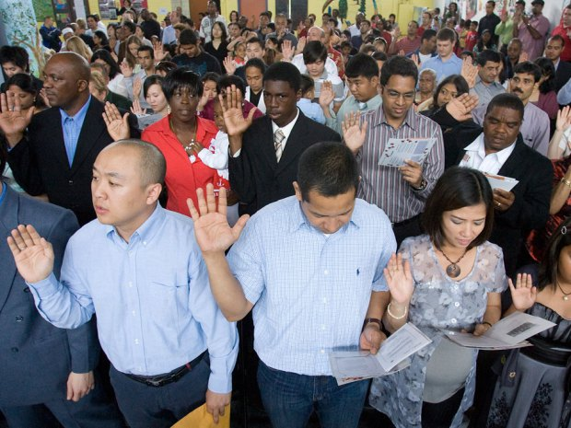

Aaron Lynett / National Post filesNew Canadian citizens take the citizenship oath during the Citizenship and Immigration Ceremony. The new survey of almost three million people shows that Canada is home to 6.8 million foreign-born residents

[**A complete graphic of the findings**](http://news.nationalpost.com/2013/05/08/young-suburban-and-mostly-asian-canadas-immigrant-population-surges/#3)

OTTAWA — The debut of Canada’s controversial census replacement survey shows there are more foreign-born people in the country than ever before, at a proportion not seen in almost a century.

They’re young, they’re suburban, and they’re mainly from Asia, although Africans are arriving in growing numbers.

[**Read the immigration and ethnocultural diversity analysis from Statistics Canada**](http://news.nationalpost.com/2013/05/08/young-suburban-and-mostly-asian-canadas-immigrant-population-surges/#1)

But the historical comparisons are few and far between in the National Household Survey, which Statistics Canada designed — at Prime Minister Stephen Harper’s behest — to replace the cancelled long-form census of the past.

The new survey of almost three million people shows that Canada is home to 6.8 million foreign-born residents — or 20.6 per cent of the population, compared with 19.8 per cent in 2006, and the highest in the G8 group of rich countries.

It also shows that aboriginal populations have surged by 20 per cent over the past five years, now representing 4.3 per cent of Canada’s population — up from 3.8 per cent in the 2006 census.

Almost one in five people living in Canada is a visible minority. And in nine different municipalities, those visible minorities are actually the majority.

**Related**

* [‘Serious’ census data consistency problems blamed on long -form cancellation](http://news.nationalpost.com/2012/10/27/serious-census-data-consistency-problems-blamed-on-long-form-cancellation/)
* [Survey shows Muslim population is fastest growing religion in Canada](http://news.nationalpost.com/2013/05/08/survey-shows-muslim-population-is-fastest-growing-religion-in-canada/)
* [Newcomers increasingly prefer the Prairies as their new home, survey finds](http://news.nationalpost.com/2013/05/08/prairies-becoming-preferred-home-for-newcomers-survey-finds/)

**Most common ethnic origins reported in survey*:**

Canadian: 10.6 million  
English: 6.5 million  
French: 5.1 million  
Scottish: 4.7 million  
Irish: 4.5 million  
German: 3.2 million  
Italian: 1.5 million  
Chinese: 1.5 million  
First Nations: 1.4 million  
Ukrainian: 1.3 million  
East Indian: 1.2 million  
Dutch: 1.1 million  
Polish: 1 million  
*\*Some respondents reported more than one ethnic origin*

However, Statistics Canada isn’t handing out detailed comparisons to the results shown in the 2006 census.

That’s because many comparisons with the past can only made reliably at a national or provincial level, said Marc Hamel, director general of the census. He said the agency suppressed data from 1,100 mainly small communities because of data quality, compared with about 200 that were suppressed in 2006. “For a voluntary survey, it has very good quality. We have a high quality of results at a national level,” said Hamel.

Until 2006, questions on immigration, aboriginals and religion were asked in the mandatory long-form census that went to one-fifth of Canadian households. When the Conservatives cancelled that part of the census in 2010, Statistics Canada replaced it with a new questionnaire that went to slightly more households, but was voluntary instead of mandatory, skewing the data when it comes to making direct comparisons.

The result is a detailed picture of what Canada looked like in 2011, but it is a static picture that in many instances lacks the context of what the country looked like in the past at the local level.

What the NHS does show is that, overwhelmingly, most recent immigrants are from Asia, including the Middle East, but to a lesser degree than in the early part of the decade. Between 2006 and 2011, 56.9 per cent of immigrants were Asian, compared with the 60 per cent of the immigrants that came between 2001 and 2005.

The Philippines was the top source country for recent immigrants, with 13 per cent, according to the National Household Survey — although a footnote warns that the survey data “is not in line” with data collected by Citizenship and Immigration Canada. China and India were second and third as source countries.

The decline in the share of Asian immigration was offset by growth in newcomers from Africa in particular, and also Caribbean countries and Central and South America.

As in the past, newcomers are settling in Canada’s biggest cities and are generally younger than the established population. Newcomers have a median age of 31.7 years, compared to the Canadian-born population median age of 37.3.

Of Canada’s 6.8 million immigrants, 91 per cent of them live in metropolitan areas, and 63.4 per cent live in the Toronto, Montreal or Vancouver areas.

**The growth and decline of religious numbers Religions by percentage increase:**

Muslim: 72.53  
Hindu: 67.68  
No religion: 63.68  
Sikh: 63.43  
Buddhist: 22.14  
Christian Orthodox: 14.82  
Jewish: -0.15  
Roman Catholic: -0.5  
Anglican: -19.83  
United: -29.29

The Toronto area continues to be the top destination for immigrants, but newcomers are increasingly settling elsewhere, especially in the Prairies. Winnipeg, Saskatoon, Calgary, Edmonton, Halifax and Montreal all saw their shares of newcomers expand compared to the 2006 census.

While Statscan did not make the comparison, the Toronto area drew in just 32.8 per cent of recent immigrants in the past five years, compared with 40.4 per cent in the 2006 census and 43.1 per cent in the 2001 census.

Analysts had been anxious to see whether province-driven immigration policies had led to growing numbers of immigrants settling in smaller towns and cities, but the NHS does not make comparisons at that level.

The survey does show that suburbs in particular are a magnet for visible minorities. The Toronto suburbs of Markham, Brampton, Mississauga and Richmond Hill all have visible minority communities that make up well over half the population. The same pattern is seen in areas around Vancouver: in Richmond, Greater Vancouver, Burnaby and Surrey.

Aboriginal Peoples are also claiming a larger share of the Canadian population. More than 1.4 million people told Statscan they had an aboriginal identity, comprising 4.3 per cent of the population compared to 3.8 per cent in the 2006 census.

The aboriginal population grew by more than 20 per cent between 2006 and 2011, compared with 5.2 per cent for the non-aboriginal population. However, Statscan warns that not all of this growth was because of people having more babies. Rather, changes in legal definitions and survey methodology account for some of the difference.

The first pack of data from 2011′s National Household Survey comes with the census equivalent of a Surgeon General’s warning: make any historical comparisons at your own risk.

Slapped across the back pages of most of the Statistics Canada documents released Wednesday is a disclaimer that the voluntary National Household Survey is an altogether different beast than the now-scrapped mandatory long-form census.

The Harper government touched off a controversy in 2010 when it decided to replace the mandatory long-form census with a voluntary survey. Demographers, analysts and insiders fretted that the quality of the data would suffer.

First Nations populations grew by 22.0 per cent, while Metis people grew 16.3 per cent and Inuit by 18.1 per cent.

While the data so far does not delve into social conditions among Aboriginal Peoples, the NHS does offer a glimpse. Aboriginal children are far more likely to be living with a single parent, usually a mother. Half the foster children under the age of 14 are aboriginal, the survey shows. And less than half of First Nations children live with both parents.

As for religion, Canadians are increasingly turning their backs. While two-thirds of Canada’s population said it was Christian, almost one quarter of respondents said they had no religious affiliation at all. That’s up from 16.5 per cent a decade earlier in the 2001 census.

At the same time, immigration patterns have led to growth in the numbers of Muslim, Hindu, Sikh and Buddhist worshippers.

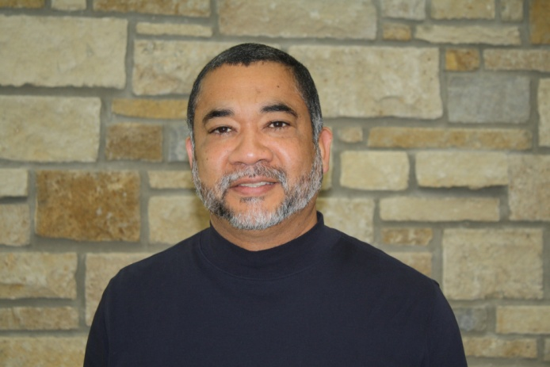

**Roberto Hodgson, Director of Multicultural Ministries**

**rhodgson@nazarene.org**

**USA/Canada Multicultural Ministries Office:** The Multicultural Ministries Office exists to support districts, pastors, local churches, and leaders in the task of making Christlike disciples among all ethnic groups in the U.S. and Canada.

# Multicultural Leadership

Multicultural Ministries USA/Canada is under the direction and leadership of Dr. Roberto Hodgson. Dr. Hodgson works in conjunction with a Multicultural Advisory Committee (MAC) of which he is the Chairman. The MAC is comprised of six ethnic facilitators. They are Rev. Charles Tillman, Rev. Rodrigo Quema, Rev. Pascal Permis, Rev. Stephen Lee, Rev. Junior Sorzano and Dr. John Nells. This advisory committee gives further direction to Multicultural Ministries in the USA/Canada.

In addition, an Ethnic Facilitator is appointed by Dr. Hodgson which has been approved by the Facilitator's District Superintendent. Each Facilitator works with a Strategic Readiness Team. Strategic Readiness Teams meet annually to pray, plan and strategize for their respective ethnic group in the USA/Canada.

**September 2013 Update from Roberto Hodgson:**

We post the information about ethnic gatherings on the USA/Canada web site "Up Coming Events". <http://usacanadaregion.org/> . We also place the report of the ethnic meetings and goals on the Multicultural Web site <http://usacanadaregion.org/multicultural-leadership>.

The Ethnic Ministries Facilitators (EMF) are resource persons for the districts. I met with them last year to provide some guidelines for working with the DSs as well as their particular ethnic group. I'm enclosing the EMF guidelines along with the guidelines for Strategy Committee members. There is an upcoming meeting September 11-13 where I'll be introducing a new concept for EMF's to serve as consultants for the DSs. The multicultural office will provide a stipend for their travel time (2-3 days). They'll be encouraged to ask if funds are available from the inviting district. After our meeting, I'm planning to send an e-mail to the DSs with some information including the travel policy guidelines to partner with MM office to cover their expenses.

At the present only Hispanic Ministries has developed a system for training with the modules. I'm working to develop something similar for the Haitian Ministries using the modules.   Next I'll work with the Koreans. The other groups are too small to realistically plan in this direction at this time.

**Ethnic Ministries Facilitators for USA/Canada**

**Ethnic Group Facilitator Home District E-Mail, Phone**

African Bleemie, Zoewah **Philadelphia** [cacotnaz@gmail.com](mailto:cacotnaz@gmail.com), 610-202-7030

Armenian Paul Doctorian **Los Angeles** [pdoctorian@aol.com](mailto:pdoctorian@aol.com), 626-798-7177

Black Charles Tillman **Virginia** [revtillman@comcast.net](mailto:revtillman@comcast.net), 917-603-8271

Cambodian Sokurt Suos **Prairie Lakes** [cambnaz@hotmail.com](mailto:cambnaz@hotmail.com), 763-535-6450

Chinese Samuel Chung **Los Angeles** [samlschung@gmail.com](mailto:samlschung@gmail.com), 626-419-6407

Filipino Rodrigo Quema **Los Angeles** [rquema@newhopenaz.com](mailto:rquema@newhopenaz.com), 818-355-7440

Haitian Pascal Permis **Southern Florida** [pascase7@aol.com](mailto:pascase7@aol.com), 772-260-5029

Hispanic Roberto Hodgson **Southwest Latin** [rchodgson@aol.com](mailto:rchodgson@aol.com), 913-961-0682

Korean Stephen Lee **Anaheim** [slee4@sbcglobal.net](mailto:slee4@sbcglobal.net), 714-719-9338

Laotian Anong Nhim **South California** [anhim@aol.com](mailto:anhim@aol.com), 562-537-7945

Messianic Jews Jack Zimmerman **Arizona** [jzimmerman@jvmi.org](mailto:jzimmerman@jvmi.org), 602-741-5789

Middle Eastern Jadallah Ghrayyeb **Colorado** [hope@vopg.com](mailto:hope@vopg.com), 719-963-3088

Multicultural Junior Sorzano **Canada Central** jrsorzano@rogers.com , 519-852-4031

Native American John Nells **Native American** [jrnells@frontier.com](mailto:jrnells@frontier.com), 602-703-6228

Portuguese **TBA**

Samoan Taulima Oge **Washington Pacific** [taulimapoto@yahoo.com](mailto:taulimapoto@yahoo.com), 253-250-8345

Secular Campus David Kyncl **Oklahoma** [kyncl@28house.org](mailto:kyncl@28house.org), 405-831-1981

Sudanese Michael Gatkek **Maine** [michael.gatkek@yahoo.com](mailto:michael.gatkek@yahoo.com), 207-272-1834

Vietnamese Chieu Pham **Central Florida** [chieu.pham1@gmail.com](mailto:chieu.pham1@gmail.com), 813-503-5014

**Guidelines for USA/Canada Ethnic Missional Facilitators  
and Strategy Committee Members**

**The Missional Facilitator**

1. Shall serve for a maximum six-year term and is not to be re-elected for this position. The facilitator would be eligible to serve for one term as a committee member after his/her term expires.
2. Shall be elected by the strategy committee from among its members or appointed by the multicultural director.
3. Shall be approved by his/her district superintendent.
4. Shall serve to develop and implement a strategic plan with the strategy committee members.
5. Shall work with the multicultural director for the implementation of the strategic plan developed by the strategy committee.
6. Shall assist the district superintendent as a consultant in matters relating to his/her ethnic group such as: new congregations, pastoral search, and church mediation, as requested by the DS.
7. Shall inform the district superintendent when an event organized by the strategy committee, such as a conference, seminar or revival, will take place in a location under the district’s geographical jurisdiction.

**Strategy Committee Members**

1. Shall serve for a maximum of four years.
2. Shall be elected by the strategy committee or appointed by the Multicultural Director in consultation with the Missional Facilitator.
3. Shall be approved by his/her district superintendent.
4. Shall work with the Missional facilitator in the development of a strategic plan and assist in its implementation.
5. Shall assist when the Missional facilitator is unable to travel to a district or a local church, and follow the same travel policy guidelines that apply to the missional facilitator.

**Travel Policy**

1. Shall inform the district superintendent when invited by a local church on that district before submitting the travel request form.
2. A Travel Request Form from the Multicultural office shall be submitted to the multicultural director for approval in accordance with the following GMC policy:
3. “It is the expectation that the funding of travel should be borne by the entity that extends the invitation or initiates the event. The use of GMC funds for travel shall be limited to those situations that are in furtherance of the strategic purpose of the position of the person travelling, the fulfillment of the strategic role of the office or department of the person travelling, and in furtherance of the strategy of the field.
4. In determining the role of travel in a particular position and the source of funding, the following questions must be asked:

* What are the expected strategic purposes of this trip?
* What are the expected strategic outcomes of the trip?
* What is the role for which the person is travelling?
* Is the travel required to fulfill the strategy of the field?
* Is the travel required to fulfill the strategy of the function?
* Who initiated the event or extended the invitation?

*By Roberto Hodgson, Multicultural Director, Sept. 2013*

**Guidelines for the District Latino-Hispanic Coordinator Job Description**

By Roberto Hodgson, Hispanic Ministries Mission Director USA/Canada

(adapted by Brian Wilson for DSLDP 2013)

**Accountability and Reporting**

The coordinator shall answer directly to the District Superintendent (D.S.).

**Duties of the Hispanic Coordinator:**

1. The D. S. shall define the expectations for the coordinator in specific cases- whether that role is to act after consultation; act and inform; or simply request the opinion of the D.S..
2. The coordinator shall serve as assistant to the D.S. in representing the Hispanic ministries of the district.
3. The coordinator shall report periodically to the District Advisory Board in the manner specified by the D.S.
4. The coordinator shall represent the Hispanic ministries to the various departments and committees of the District according to the discretion of the D.S..
5. The coordinator shall develop and present to the D.S. a plan outlining specific strategies for establishing and developing Hispanic ministries for the district.
6. The coordinator shall serve as the catalyst and visionary agent for the new Hispanic congregations of the district.
7. In consultation with the D.S., the coordinator will seek, interview, and select pastors for the establishing of new congregations.
8. The coordinator shall assist in the development of new congregations - guiding them toward the status of organized churches.
9. The coordinator shall serve as the contact person and be available for advice and counsel to those who express interest in initiating a new Latino-Hispanic ministry.
10. The coordinator shall assist the board or committee of a local church in the process of searching for a new pastor.
11. The coordinator shall serve as a mediator when any of the Latino-Hispanic congregations face internal or external conflicts.
12. The coordinator shall counsel pastors and churches regarding legal processes (such as incorporation) according to local, state, and federal law.
13. The coordinator shall organize specific continuing education events for pastors and general activities to support their ministries.
14. The coordinator shall provide opportunities for fellowship and interaction among pastors on specific occasions planned for that purpose.
15. The coordinator shall organize and assist in the celebration of camps and retreats for the Hispanic-Latino churches.
16. The coordinator shall define, in consultation with the D.S., the zone division of the Latino churches for the purposes of fellowship among the pastors and congregations, evangelism, and other growth - oriented activities.
17. The coordinator shall establish the Hispanic Ministerial Studies Program for ordination.
18. The coordinator shall advise in the planning and development of the courses and curriculum of the Ministerial Studies Program.

**Nazarene Compassionate Ministries, USA/Canada**



**Jay Height,** [**jheight@nazarene.org**](mailto:jheight@nazarene.org)

**Coordinator, Nazarene Compassionate Ministries**

**September 3, 2013 Update from Jay– Some things you may be interested in:**

* We will be starting our second leadership cohort for compassionate ministries leaders. This two year program teaches various aspects. It is done by monthly webinars and twice a year in-person meetings.
* We will be hosting a compassionate ministries national conference in October 2014.
* We have started a monthly newsletter with information for urban pastors and CMC (Compassionate Ministry Center) leaders. Email me to get signed up. Past issues are on website at <http://usacanadaregion.org/nazarene-compassionate-ministries-newsletter>
* We are building a team of various leaders to lead conversations about these issues. If a DS has someone to serve on a team let me know:
  + Building coalitions
  + Human trafficking – Jaime Gates
  + Hunger
  + Homeless
  + Economic development – Brian Postelwait
  + Immigration – Iowa
  + Youth – Andrew
  + Urban Churches – pastor lower lights/new year
  + Top urban centers – DS
  + Medical – Dr from lower lights
  + Apex – Jerry Appleby
  + Urban Church Planting – Chuck Russ
  + Prison Ministries Reentry – Althea Taylor
  + Drug Rehab
  + Learning Disabilities
* We are available to do training for districts to help pastors deal with the growth of poverty in the suburbs.
* Also, the third week of January 2014, in Indianapolis, urban church planting training will take place with Bill Wiesman.