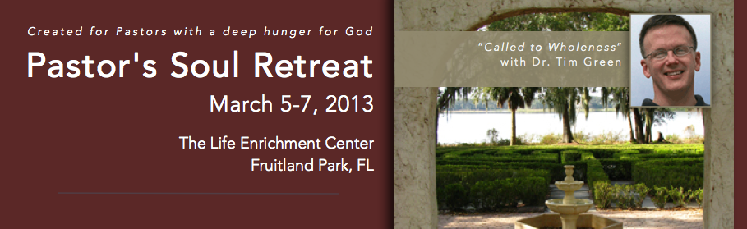

Agenda
  - Tuesday
2:00 – 5:00 pm Early Registration
5:30 – 6:30 pm Dinner
7:00 – 7:20 pm Pre-Opening Prayer (in Prayer Chapel – Building #13 on Map)
7:30 – 9:00 pm Opening Session - “The Call: An Undivided Heart”, Joshua 24

  - Wednesday
8:00 - 8:45am Breakfast
9:00 - 10:15am 2nd Session - “The Dilemma: Holy Hills and Sacred Cows”—Deut. 6:4-5
10:15 - 10:45am Break
10:45 – 12:00pm 3rd Session - “Leopard’s Spots and Ethiopian Skin: Is There Any Hope?”
Jer. 31:31-33
12:00 -12:45pm Lunch
1:00 – 5:00 pm Free Time
Available on-site: book store, nature trail, prayer chapel and labyrinth, volleyball, horseshoe and board games in Lobby.
Short drive: Low Ropes Challenge*, Lake Griffin State Park (http://floridastateparks.org/lakegriffin/)
Group Activities (pre-registration required)
6:00- 6:45 pm Dinner
7:00 – 8:45 pm 4th Session - “Glory Bearers: Holiness and Mission”—Ex. 24:15-18; 40:34-38; Ez 10:18-19

  - Thursday
8:00 - 8:45am Breakfast
9:00 - 10:15am 5^{h} Session (Closing) - “The Mind of Christ”—Mark 8-10
Communion
10:30 am Check Out

