The Creswell Church of the Nazarene located in Creswell, Oregon is offering their Missionary Bivouac to any missionary or minister in the Nazarene church starting today! It is perfect for missionaries, superintendents, and pastors. Ideal for quiet sabbaticals, missionary furloughs, weekend getaways, a writer’s haven, a pastor’s vacation, etc.
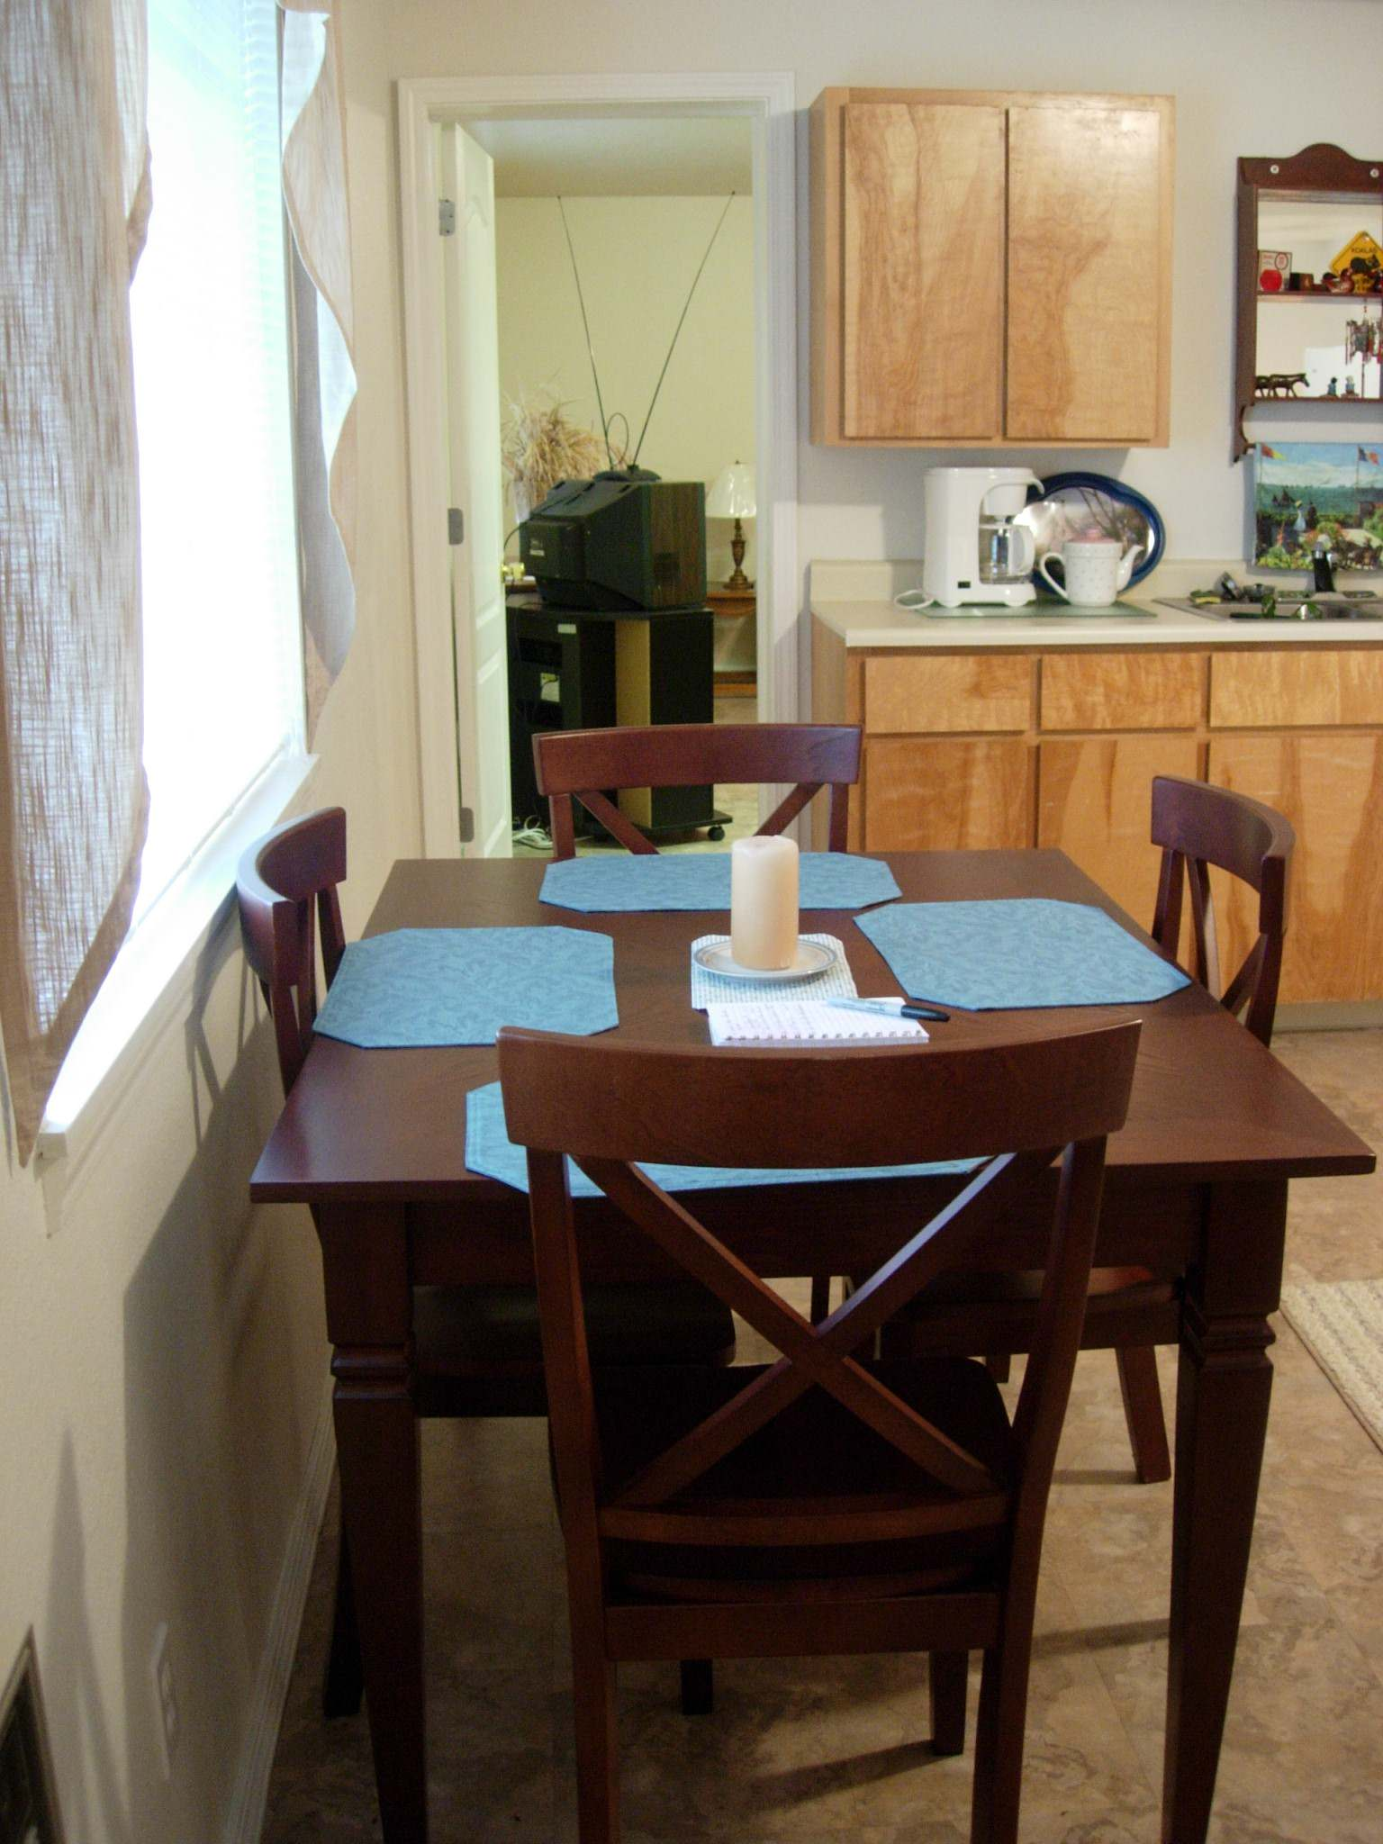
Our modern 800 square foot 2 bedroom / 2 bath home sleeps six comfortably. It features a full kitchen, dining room, relaxing den, and is fully furnished throughout.

Located in the lush Willamette Valley of western Oregon, the Pacific Ocean is only 1½ hours away. A 2½ hour drive will get you to the Portland airport, 4 hours to the California redwoods and 2 hours to the snowy slopes of the Cascades for skiing.

Our district wants to minister to our ministers and missionaries in this way so please use us. Stays are completely free.

For more information or to reserve dates contact:

April Fisk, Local Bivouac Coordinator, (541) 895-2379, fiskanc@netzero.net or
Kathi Kinnaman, Oregon-Pacific District Deputation Secretary, (503) 640-3065, Kathi.Kinnaman@juno.com.
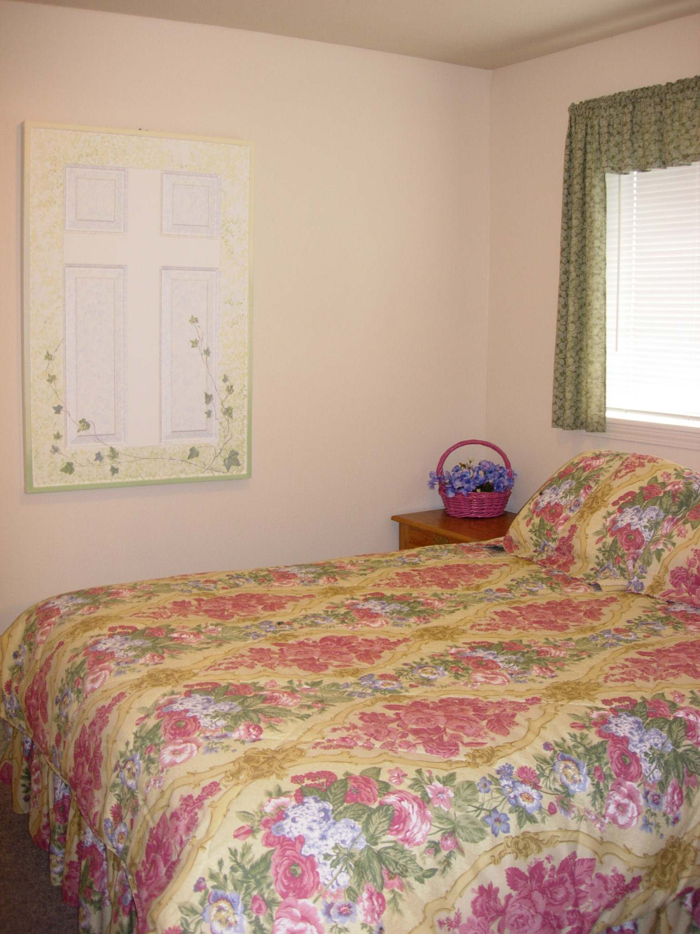
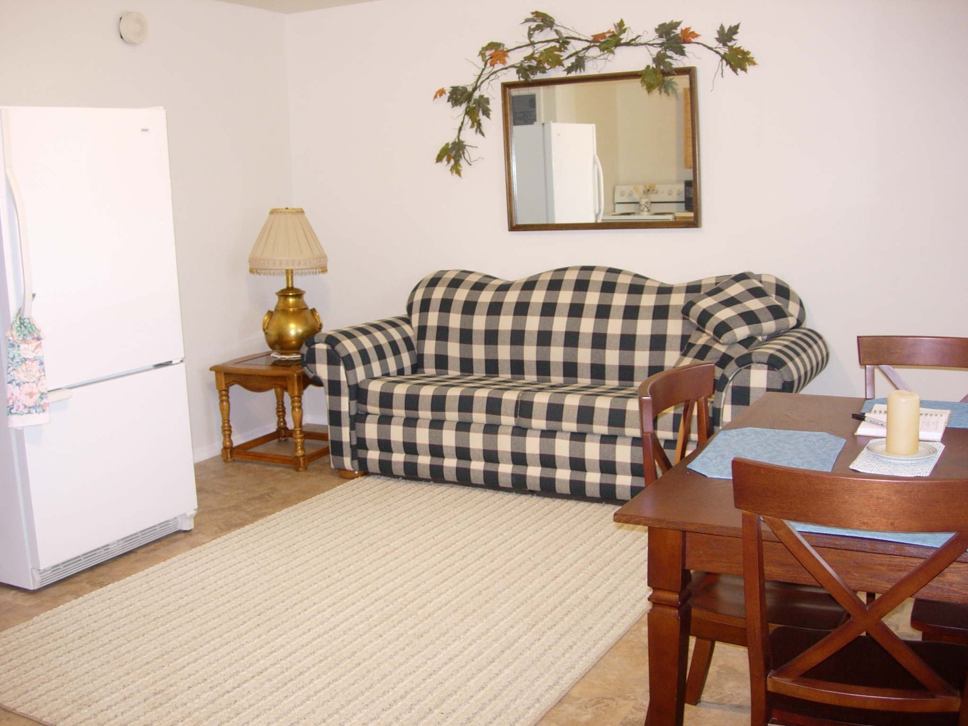

Spend time with God in a quiet place.

